September 1, 2018

Dear ________________,

On behalf of the Colleyville Lions Club, I would like to thank you for considering our Sponsorship support. We are having our 23rd annual ”Breakfast with Santa” on Saturday, December 1, 2018, and would like you to join us, as a sponsor and guest.

We had over 1,400 children and adults attend the Breakfast with Santa last year. It was a great community event raising over $27,500 Net. Funds were distributed directly to 19 Lion supported Charities. This included free vision screening and eye glasses for adults and children; the Special Needs Assistance Program (SNAP) for Down Syndrome persons, Mid-Cities Supporter of Safe-Haven (SOS) For Battered Women and Children, Texas Lions Camp Bus Transportation, Large Print Books for the Colleyville Library, Police Special Olympics, Sports Extravaganza for Sight Impaired Participants, Juvenile Diabetes Research Foundation, Computers for the Blind, Hope Farm, GCISD Food Pantry, JDRF, Colleyville LEO Club, Middle School Choir Booster Clubs, Texas Lions Foundation, Leader Dog, Anchors for Life and College Scholarships. The event also supported pictures with Santa and Breakfast on Christmas Eve for the children at the Presbyterian Night Shelter. We also collected over 1,400 lbs. of food for GRACE and Eye Glasses to recycle. This could not be possible without your support as a valued Sponsor.
We have included a copy of the “Breakfast with Santa” agreement for your review and records. We would like to finalize our sponsor list this year by November 1st to allow time to format and distribute promotional materials. Simply return the attached Contract and donation with your camera-ready art logo.

Through your generosity, we can continue to support our community and these services. Please feel free to contact us at 817.994.6180(Dr. Miller) or 817.300-0081(Tom).

In Service,
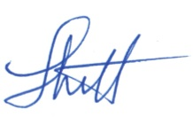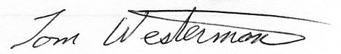
Dr. Louis Miller Tom Westerman
(Co-Chair) (Co-Chair)
http://www.colleyvillelions.com

